Hnefatafl
The Viking Game
To play this game like a good Norseman the correct steps to follow are:
- Head to the bar and pick up a big jug of something to drink while you are doing the rest of the steps. (Yes its period – documentation is at the end.)
- Sit down somewhere comfy with a friend or, lacking any handy friends, grab the first person that walks by and sit them down with a drink.
- While drinking sort out what set of rules you are going to play by and what size board you will be using. The rest of this article is the version I like most.
- Grab your knife and carve a quick grid into the table in front of you. Make it 13 squares by 13 Squares. Put an “X” in the center and in each corner.
- Grab a big piece of antler and put it in the center square. This is called the King.
- Place twelve smaller pieces of antler in four groups of three going out from the center square to each principal direction (top, bottom, left, right). If the drink is going to your head there’s a picture below. These are the defenders.
- Grab 24 rocks. Place 5 of them on each edge of the board centered along the edge. Place the remaining 4 rocks just inside of the groups of five on the same lines as the three defenders. The rocks are the attackers.
- Decide who is attacking and who is defending. Hint – according to the sagas the defender usually wins but the attacker moves first (its an attack after all).
- Play and drink. (I said period didn’t I?)

The board layout
X |  |  |  | A | A | A | A | A |  |  |  | X
 |  |  |  |  |  | A
 |  |  |  |  |  | D
A |  |  |  |  |  | D |  |  |  |  |  | A
A |  |  |  |  |  | D |  |  |  |  |  | A
A | A |  | D | D | D | K | D | D | D |  | A | A
A |  |  |  |  |  | D |  |  |  |  |  | A
A |  |  |  |  |  | D |  |  |  |  |  | A
 |  |  |  |  |  | D
 |  |  |  |  |  | A
X |  |  |  | A | A | A | A | A |  |  |  | X

The rules:

- There are no diagonals in this game.
- Every piece has exactly the same move - as far as you want in any of the principal directions. Yes the king too.
- The attacker is trying to kill the king.
- The defender is trying to get the king safely to a corner.
- All of the squares with “x” in them belong to the king. No-one else can stop on those squares.

How do you “kill” a piece?

Every piece is a Viking warrior. That means that one-on-one there is no way to kill a piece. (Vikings after all are the best fighters.) So you gang up on them. Keep his attention focused on a player in front, then have a friend run up behind and hit him in the head with an axe – like this:

A |  | A
D | → | D
 |  | A
A

This “kills” the defender and he is removed from the board. It also works horizontally but not using diagonals.

Some other “killer” moves include

D | A |  | D | → | D | A | D

A |  | D | A |  | A | D | A
 | D |  |  | → | D
 | A |  |  |  | A

The first example kills one attacker.
The second kills two defenders.

These moves don’t kill any pieces:

A | D | D |  | A | → | A | D | D | A

D |  | A | → | D | A
A |  |  |  | A

A |  | A | → | A | D | A
 | D

A |  | A |  |  |  | A
 | D |  | → |  | D
 |  |  |  | A

How do you “kill” the king?

The king is the best fighter, of course, so he can only be killed by being attacked on all four sides at the same time. Remember – the king is a defender just like any other piece and thus can be used to help kill attackers.

Variations on a Theme

So now that you’ve played a game or two and noticed that the game is rather unfair here are some changes you can apply to make the game more even.

If the king is winning too often:

- Require the defender to say “Raichi” (check) when a winning move is available.
- Require only two men to kill the king.

If the Attacker is winning too often:

- The king is only required to get to the side of the board to win.
- Count the corners as an “opposing piece”. If the attacker is beside the corner than a single piece on his other side can kill him.

You can also try a different Board or set of starting positions – see my website for some alternatives.

The History

Long version of the documentation is on my website.

We know of the following boards or pieces of boards: Knockanboy, Ireland. 7x7; Ballindary Ireland 7x7; 3 boards from the Orkneys (7x7); Faroes (13x13); Trondheim (11x11); Wimose (19x19??); Gokstad (13x13); and Coppergate (York) (19x19??).

I have records of at least 138 playing pieces discovered. They are made of various materials including soapstone, amber, jet, ivory, bone, antler, stone, tusk, glass, and bronze.

Saga evidence comes from Erybyggja Saga, Grettir’s Saga, Heimskringla, Kormac’s Saga, Volsung Saga, Orkneyinga Saga, Greenland Lay of Atli, Hervar's Saga, Fridthjof's Saga, and Gunnlaugs Saga Ormstunga

Other than the sagas there is Carl Linne’s diary of July 1732, manuscripts Peniarth #158 - Robert ap Ifan 1587, and Oxon 122 - c. 925, and references in Dimetin Code, the Laws of Howel Dha, and the Book of Rights.

And finally I thought I would document the drinking. Although several sagas mention the connection my personal single favourite piece is the stone carving from Ockelbo, Sweden.

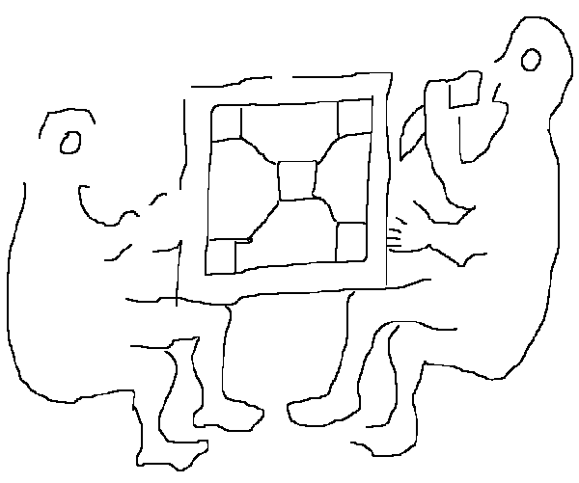

I hope you have fun playing. Feel free to drop by the web site and have a look at the historical articles that support this “very short” article. http://www.treheima.ca/viking

Even better find me at an event, grab a beer (and one for me) come on over and we’ll play a game…..

Ragnarr

© Neil Peterson, 2001

